You Are Invited To The

Cape Fear Ballroom Dancers

HolidayDinner-Dance

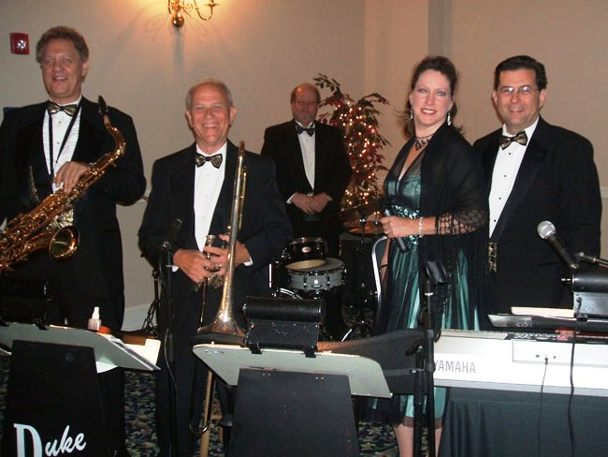

Music by the Duke Ladd Orchestra

Wednesday, December 11, 2024

Hellenic Center, 614 Oakridge Ave

Dinner by Dorothy’s Catering

6:30 Social 7:00 Dinner

8:00 – 10:00 Dancing

Admission – $75.00 per person

$25.00 discount for CFBD members

Ladies: Cocktail Dress, Semi-formal, or Formal Gentlemen: Tuxedo (preferred)

Pre-Paid Reservations required by **Dec 2**– check payable to: Cape Fear Ballroom Dancers.

Mail check & reservation form to: Cape Fear Ballroom Dancers, PO Box 1359, Fayetteville, NC 28302.

For more information, call 910-987-4420 or go to [www.capefearballroomdancers.org](http://www.capefearballroomdancers.org)

**Or pay ONLINE with a credit card at** [**https://cape-fear-ballroom-dancers.square.site**](https://cape-fear-ballroom-dancers.square.site)

***Please specify below any special dietary requirements, e.g. allergies, vegetarian meal, no fish, etc.***

*Cut here *

Name: __________________________________________ ◻ **$75**  ◻ **$50** CFBD member

Name: __________________________________________ ◻ **$75**  ◻ **$50** CFBD Member

Please list names of those who wish to sit at the same table (limited to 8 people):

Please give us a phone number where we may notify you if needed: ____________________________