You Are Invited To The

Cape Fear Ballroom Dancers

HolidayDinner-Dance

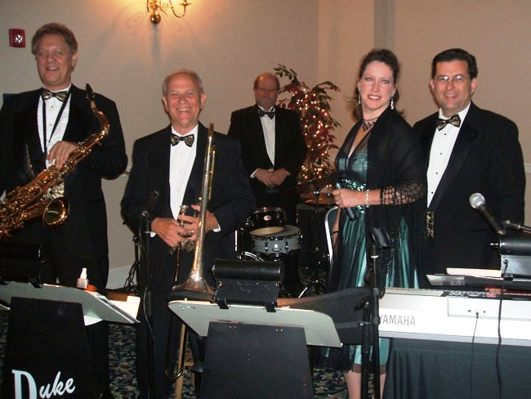

With Music by the Duke Ladd Orchestra

Wednesday, December 11, 2019

Highland Country Club

6:30 Social 7:00 Dinner

8:00 – 10:00 Dancing

Admission – $60.00 per person

$10.00 discount for CFBD members

Ladies: Cocktail Dress, Semi-formal, or Formal Gentlemen: Tuxedo (preferred)

Pre-Paid Reservations required by **Dec 6** – check payable to: Cape Fear Ballroom Dancers.

Mail check & reservation form to: Cape Fear Ballroom Dancers, PO Box 1359, Fayetteville, NC 28302.

For more information, call 910-987-4420 or go to [www.capefearballroomdancers.org](http://www.capefearballroomdancers.org)

***Please specify below any special dietary requirements; e.g. allergies, vegetarian meal, etc. People may be responsible for any additional cost for a special meal.***

*Cut here ✂*

Name: __________________________________________ 🞎 **$60**  🞎 **$50** CFBD member

Name: __________________________________________ 🞎 **$60** 🞎 **$50** CFBD Member

Please list names of those who wish to sit at the same table (limited to 8 people):

Please give us a phone number where we may notify you if needed: ____________________________